**University Workshop Series**

**Power Query**

**Hands-on Training Lab**

**Lester Sim**

Business Analyst

Data & AI, Global Black Belt

Content Page

Environment Set Up 3

Importing of Data 4

Importing a Single File 4

Create a Data Model in Excel 4

Create Relationships between Tables 5

Use a Data Model to create a PivotTable or PivotChart 5

Importing from a Folder of Files 6

Other Data Sources 6

Merging Data 6

Different Types of Merge 6

Fuzzy Matching 8

Reshaping Data 9

Pivot 9

Unpivot 11

References 12

# Environment Set Up

1. Download files from <https://github.com/lestersimjj/MSLearnPowerQuery>
2. Check your version of Excel. No installation required for Excel 2016 and above. Power Query is included in those versions
3. Click the Data tab of the Ribbon and you should see the following screen



1. Otherwise, click File > Options > Customize Ribbon and ensure that the Data checkbox is checked

1. To enable the Power Pivot Ribbon, click **File** > **Options** > **Add-ins** > Click **Microsoft Power Pivot for Excel**
2. At the bottom of the window click **Manage** > **COM Add-ins** > **Go**

# Importing of Data

## Importing a Single File

1. Select **Data** > **Get Data** > **From File** > **From Workbook**.

1. In the **Excel Browse** dialog box, browse for or type a path to the file that you want to query.
2. Select **Open**.

## Create a Data Model in Excel

1. Select **Data** > **Get & Transform Data** > **Get Data** to import data
2. Excel prompts you to select a table. If you want to get multiple tables from the same data source, check the **Enable selection of multiple tables** option. When you select multiple tables, Excel automatically creates a Data Model for you.

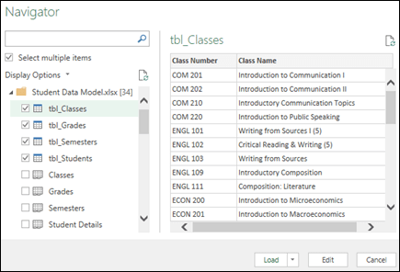

1. Select the 4 tables, then click **Load**.

## Create Relationships between Tables

1. Go to **Power Pivot** > **Manage**.
2. On the **Home** tab, select **Diagram View**.
3. Next, drag the primary key field from one table to the next. The following example is the Diagram View of our student tables:

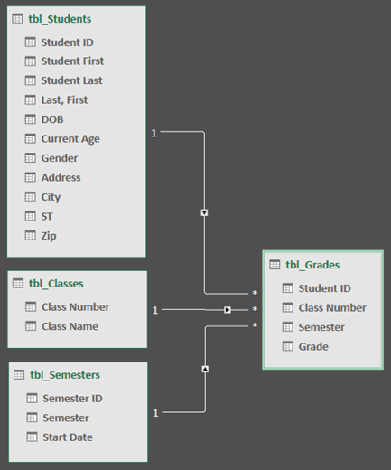

tbl_Students | Student ID > tbl_Grades | Student ID

tbl_Semesters | Semester ID > tbl_Grades | Semester

tbl_Classes | Class Number > tbl_Grades | Class Number

## Use a Data Model to create a PivotTable or PivotChart

1. On the **Home** tab, select **PivotTable** > **From Data Model**
2. Add the appropriate fields from the **Field List**

## Importing from a Folder of Files

1. Select **Data** > **Get Data** > **From File** >**From Folder**. The **Browse**dialog box appears.

1. Locate the folder containing the files you want to combine.
2. A list of the files in the folder appears in the <Folder path> dialog box. Verify that all the files you want are listed.
3. Select **Combine**> **Combine & Load**.
4. In the **Sample File** box, select a file to use as sample data used to create the queries. You can either not select an object or select just one object. But, you can't select more than one.
5. Select **OK**.

## Other Data Sources

From Database

From Azure

Others

# Merging Data

## Different Types of Merge

1. Select **Get Data > Combine Queries > Merge.** The Merge dialog box appears.

1. Select the primary table from the first drop-down list, and then select a join column by selecting the column header.
2. Select the related table from the next drop-down list, and then select a matching column by selecting the column header.
3. The default join operation is an inner join, but from the **Join Kind** drop down list, you can select the following types of join operations:

**Inner join**    Brings in only matching rows from both the primary and related tables.  
  
**Left outer join**    Keeps all the rows from the primary table and brings in any matching rows from the related table.  
  
**Right outer join**    Keeps all the rows from the related table and brings in any matching rows from the primary table.  
  
**Full outer**   Brings in all the rows from both the primary and related tables.  
  
**Left anti join**    Brings in only rows from the primary table that don't have any matching rows from the related table.  
  
**Right anti join**    Brings in only rows from the related table that don't have any matching rows from the primary table.  
  
**Cross join**    Returns the Cartesian product of rows from both tables by combining each row from the primary table with each row from the related table.

1. Select Ok
2. In the Data Preview, select the Expand icon next to the NewColumn column header.
3. In the Expand drop-down box, select or clear the columns to display the results you want. To aggregate the column values, select Aggregate.

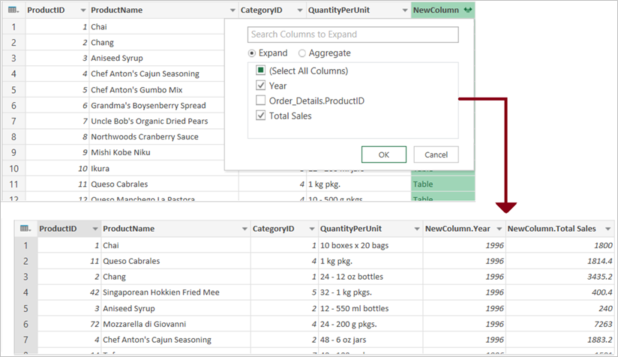

## Fuzzy Matching

1. **Select Home**> **Combine** > **Merge Queries**. You can also select **Merge Queries as New**. The Merge dialog box appears with the primary table at the top.
2. Select the column you want to use for your fuzzy match. In this example, we select First Name.
3. From the drop-down list, select the secondary table, and then select the corresponding fuzzy match column. In this example, we select First Name.
4. Select a **Join Kind**. There are several different ways to join. Left Outer is the default and the most common. For more information on each kind of join, see [Merge queries.](https://support.microsoft.com/en-us/office/merge-queries-power-query-fd157620-5470-4c0f-b132-7ca2616d17f9)
5. Select **Use fuzzy matching to perform the merge**, select **Fuzzy matching options**, andthen select from the following options:
   1. **Similarity Threshold**   Indicates how similar two values need to be in order to match. The minimum value of 0.00 causes all values to match each other. The maximum value of 1.00 only allows exact matches. The default value is 0.80.
   2. **Ignore case**    Indicates whether text values should be compared in a case sensitive or insensitive manner. The default behavior is case insensitive, which means case is ignored.
   3. **Maximum number of matches**    Controls the maximum number of matching rows that will be returned for each input row. For example, if you only want to find one matching row for each input row, specify a value of 1. The default behavior is to return all matches.
   4. **Transformation table**   Specify another query that holds a mapping table, so that some values can be auto-mapped as part of the matching logic. For example, defining a two-column table with a “From” and “To” text columns with values “Microsoft” and “MSFT” will make these two values be considered the same (similarity score of 1.00).
6. Power Query analyzes both tables, and displays a message about how many matches it made. In the example, the selection matches 3 of 4 rows from the first table. Without using fuzzy matching, only 2 of 4 rows would match.
7. If you're satisfied, select **OK**. If not, try different **Fuzzy merge options**to customize your experience.

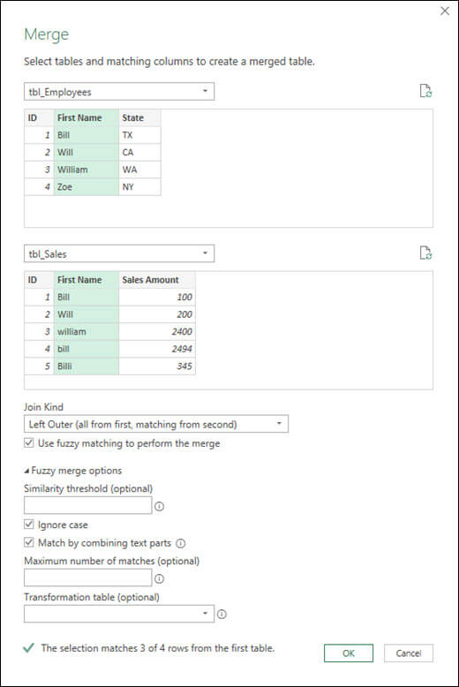

# Reshaping Data

## Pivot

1. Import the Excel file > Transform
2. Select the column that you want to pivot. In this case, select Date
3. On the Transform tab in the Any column group, select Pivot column.

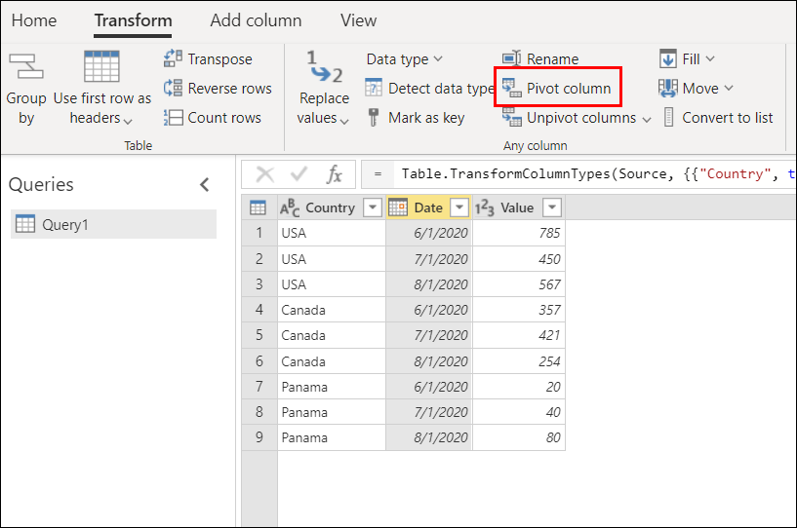

1. In the Pivot column dialog box, in the Value column list, select Value.

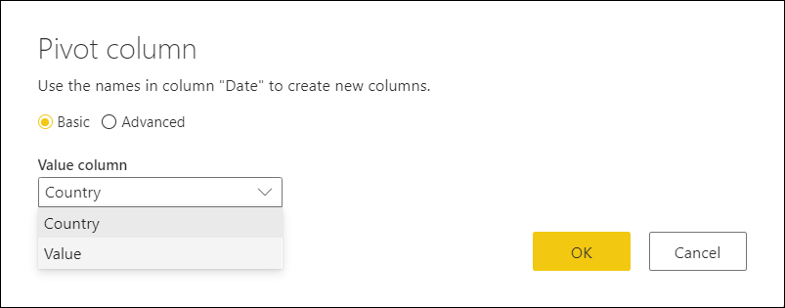

1. By default, Power Query will try to do a sum as the aggregation, but you can select the Advanced option to see other available aggregations.

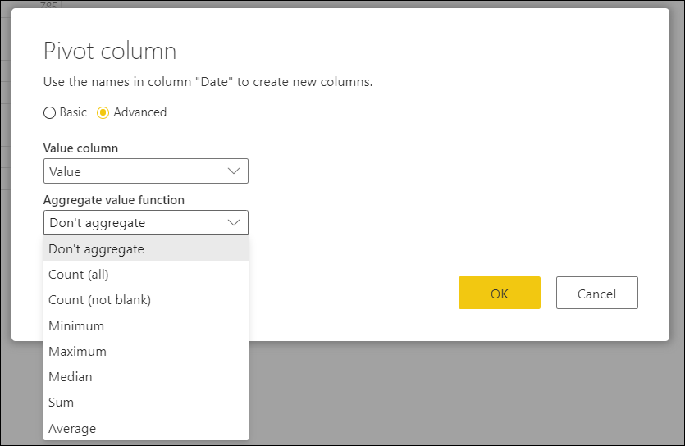

## Unpivot

1. Import the Excel file > Transform
2. Select all the columns except Country. To select more than one column contiguously or discontiguously, press Shift+Click or CTRL+Click on each subsequent column.

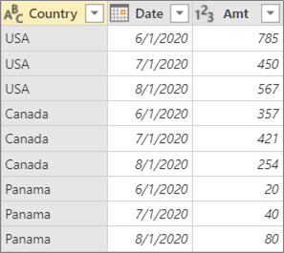

1. Select Transform > Unpivot Columns.



# References

<https://support.microsoft.com/en-us/office/import-data-from-external-data-sources-power-query-be4330b3-5356-486c-a168-b68e9e616f5a>

<https://support.microsoft.com/en-us/office/import-data-from-a-folder-with-multiple-files-power-query-94b8023c-2e66-4f6b-8c78-6a00041c90e4>

<https://support.microsoft.com/en-us/office/merge-queries-power-query-fd157620-5470-4c0f-b132-7ca2616d17f9>

<https://support.microsoft.com/en-us/office/create-a-fuzzy-match-power-query-ffdd5082-c0c8-4c8e-a794-bd3962b90649>

<https://docs.microsoft.com/en-us/power-query/pivot-columns>

<https://support.microsoft.com/en-us/office/unpivot-columns-power-query-0f7bad4b-9ea1-49c1-9d95-f588221c7098>